**Methods of vehicle lateral controls**

**Introduction**- In this article, we discuss three method of vehicle lateral control: Pure pursuit, Stanley, and MPC combined with the result of a project of controlling the vehicle to follow a race track.

**Pure Pursuit Controller-** Pure pursuit is the geometric path tracking controller. A geometric path tracking controller is any controller that tracks a reference path using only the geometry of the vehicle kinematics and the reference path. Pure Pursuit controller uses a look-ahead point which is a fixed distance on the reference path ahead of the vehicle as follows. The vehicle needs to proceed to that point using a steering angle which we need to compute.

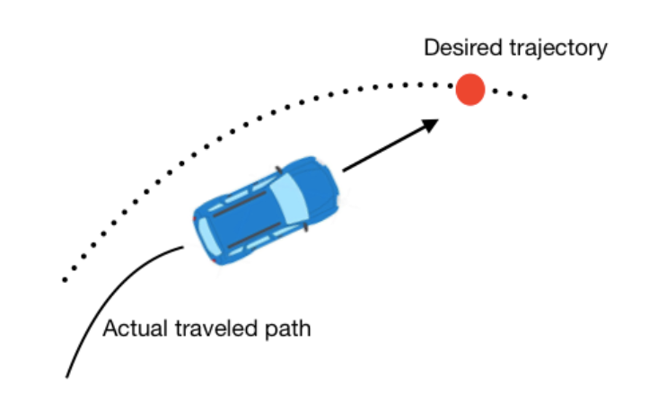

Figure1.

In this method, the center of the rear axle is used as the reference point on the vehicle.

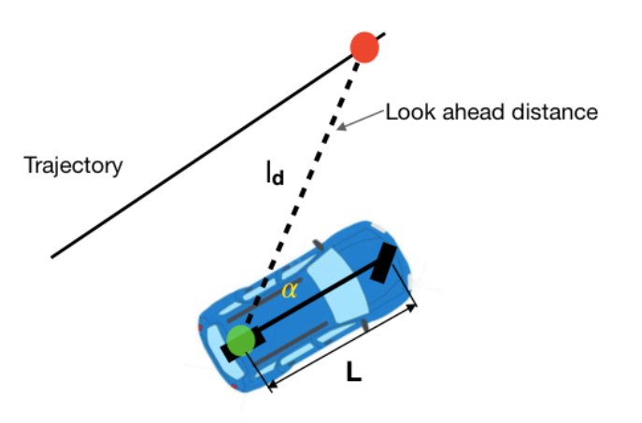

Figure2.

**The target point** is selected as the red point in the above figure. And the distance between the rear axle and the target point is denoted as *ld*. Our target is to make the vehicle steer at a correct angle and then proceed to that point. So, the geometric relationship figure is as follows, the angle between the vehicle's body heading and the look-ahead line is referred to as α. Because the vehicle is a rigid body and proceeds around the circle. The instantaneous center of rotation (ICR) of this circle is shown as follows and the radius is denoted as R.

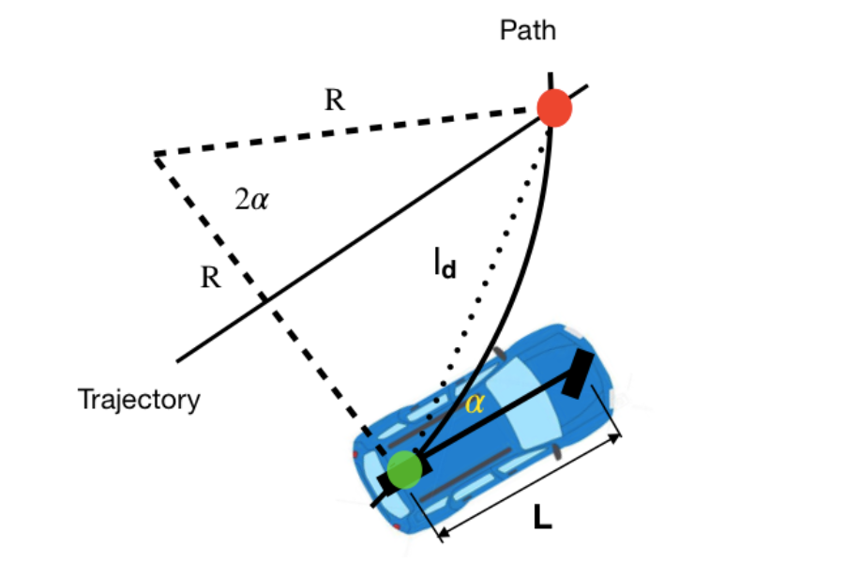

Figure3.

$$\frac{ld}{sin2α}=\frac{R}{sin⁡\left(\frac{π}{2}-α\right)}$$

$$\frac{ld}{2sinαcosα}=\frac{R}{cos⁡\left(α\right)}$$

$$\frac{ld}{sinα}=2R$$

$$k=\frac{1}{R}=\frac{2sinα}{ld}$$

K is the curvature.

$$\frac{L}{tan⁡(δ)}=R$$

So, the steering angle $δ$ can be calculated as:

$$δ=arctan\left(\frac{2Lsinα}{ld}\right)$$

The pure pursuit controller is a simple control. It ignores dynamic forces on the vehicles and assumes the no-slip condition holds at the wheels. Moreover, if it is tuned for low speed, the controller would be dangerously aggressive at high speeds. One improvement is to vary the **look-ahead distance *ld*** based on the speed of the vehicle.

$$ld=Kdd*Vf$$

So steering angle become as:

$$δ=arctan\left(\frac{2Lsinα}{Kdd*Vf}\right)$$

Advantages- If we talk about what is the cross-track error in this case. First, the cross-track error is defined as the lateral distance between the heading vector and the target point as follows. If the cross-track error is smaller, that means our vehicle follows the path better.

$$sin⁡(α)=\left(\frac{e}{ld}\right)$$

$$k=\left(\frac{2sinα}{ld}\right)$$

$$k=\left(\frac{2}{ld^{2}}e\right)$$

The above equation shows that the curvature k is proportional to the cross-track error. As the error increases, so does the curvature, bringing the vehicle back to the path more aggressively. The proportional gain 2/ld2 can be tuned by yourself. In short, pure pursuit control works as a proportional controller of the steering angle operating on the cross-track error. The cross-track error can be reduced by controlling the steering angle, so this method works.

**Stanley controller-**

Secondly, we will discuss Stanley Controller. It is the path tracking approach used by Standford University's DARPA Grand Challenge team. Different from the pure pursuit method using the rear axle as its reference point, Stanley method use **the front axle**as its reference point. Meanwhile, it looks at both the **heading error and cross-track error**. In this method, the cross-track error is defined as the distance between the closest point on the path with the front axle of the vehicle.

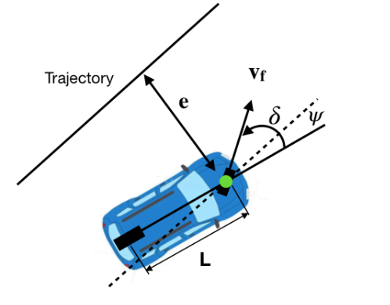

Figure4.

**Mathematical formulation-**

ψ is heading error which refers to the angle between the trajectory heading and the vehicle heading. The steering angle is denoted as δ. There are three intuitive steering laws of Stanley method,

Firstly, eliminating the heading error. δ (t)= ψ(t).

Secondly, eliminating the cross-track error. This step is to find the closest point between the path and the vehicle which is denoted as e(t). The steering angle can be corrected as follows,

$$δ\left(t\right)=\tan^{-1}\left(\frac{ke\left(t\right)}{vf\left(t\right)}\right)$$

Modified above equation

$$δ\left(t\right)=ψ(t){ + tan}^{-1}\left(\frac{ke\left(t\right)}{vf\left(t\right)}\right)$$

**Advantages-** Stanley controller not only considers the heading error but also corrects the cross-track error.

Stanley controller not only considers the heading error but also corrects the cross-track error. Let's look at these two scenarios,

Firstly, if the heading error is large and cross-track error is small, that means ψ is large, so the steering angle δ will be large as well and **steer in the opposite direction** to correct the heading error, which can bring the vehicle orientation as same as the trajectory.

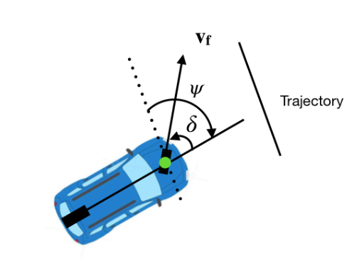

Figure5.

Supposing the heading error ψ(t) =0, δ(t) will be π/2. That makes the vehicle **run towards the path**as follows,

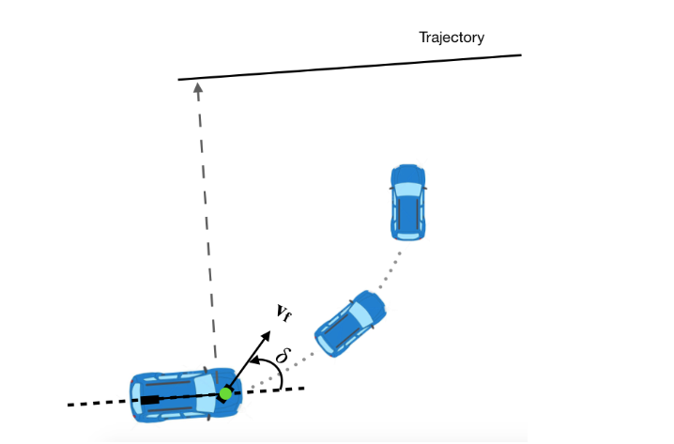 Figure6.

As the heading changes due to the steering angle, the heading correction counteracts the cross-track correction and drives the steering angle back to zero. When the vehicle approaches the path, cross-track error drops and the steering angle starts to **correct the heading alignment**.

In short, the Stanley controller is a simple but effective and steady method for later control. These two methods are both geometric controllers. We will discuss another non-geometric controller which is the Model Predictive Controller known as MPC.

**Model Predictive Controller-**

**Cost Function-** We should first know the **cost function.** For example, in this project, we want to control the vehicle to follow a race track. So, the cost function should contain the **deviation from the reference path**, smaller deviation better results. Meanwhile, **minimization of control command magnitude** in order to make passengers in the car feel comfortable while traveling, smaller steering better results. This is similar to the optimization problem of optimal control theory and trades off control performance and input aggressiveness. Above these two targets, we can arrive the cost function as,

The main concept of MPC is to use a model of the plant to predict the future evolution of the system[2]. In this case, we can use the simple kinematic bicycle model as follows, if you are not familiar with it.

x_dot = v * cos(δ + θ)

y_dot = v * sin(δ + θ)

θ_dot = v / R = v / (L/sin(δ)) = v * sin(δ)/L

δ_dot = φ

x_(t+1) = x_t + x_dot * Δt

y_(t+1) = y_t + y_dot * Δt

θ_(t+1) = θ_t + θ_dot * Δt

δ_(t+1) = δ_t + δ_dot * Δt

The states X are [x, y, θ, δ], θ is heading angle, δ is steering angle. Our inputs U are [ν, φ], ν is velocity, φ is steering rate.

### **MPC Structure-**

Now, we have the cost function and the predictive model. The next step is to seek the best inputs to optimize our cost function. We can summarize the whole MPC process as follows as,

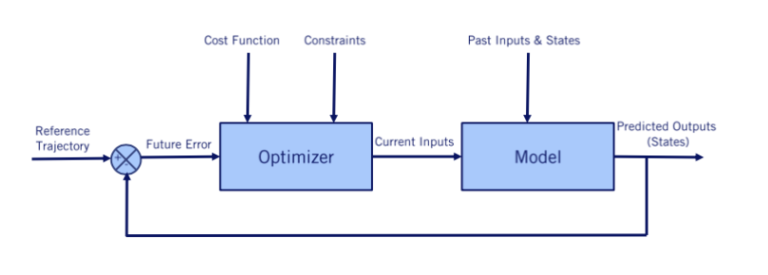

Figure7.

So how to find the best control policy U? In this case, U is the steering angle.

1. Firstly, suppose our steering angle bounds are δ(t)∈ [δmin, δmax]. I use a simple method that discrete the input of the model, which is the steering angle δ into values with the same interval.
2. Then we can get the predicted outputs which are [x, y, θ, δ] using the above model and the input δ.
3. The last step is to select the smallest value of the cost function and its corresponding inputs δ. (In this case, we divided steering angle with 0.1 intervals from δmin -1.2 to δmax 1.2 radians. Then put it into the cost function and for loop to find the minimum value and its corresponding input δ.)
4. Repeat the above process in each time step.

**Advantages-**

MPC has a lot of advantages. It can also be applied to linear or nonlinear models. It has a straightforward formulation and it can handle multiple constraints. For example, it can incorporate the low-level controller, adding constraints for Engine map, fully dynamic vehicle model, Actuator models, Tire force models. And the cost function can be designed for different targets. For example, it can penalize collision, distance from the pre-computed offline trajectory, and the lateral offset from the current trajectory and so on. MPC is much more flexible and general. But it also has disadvantages of **computationally expensive**. Especially for the non-linear model, which is very general and even our bicycle model is also in this category, MPC must be solved numerically and cannot provide a closed-form solution.